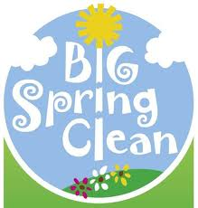
Spring Cleaning With a Purpose

Flowers are blooming, the birds are chirping and the weather is warming up. Spring is here!!! It’s the time of year that we’ve all been waiting for… time for Spring Cleaning, yeah! While many of us have long lists of projects that we’ve thought about all winter long, spring is the ideal time to be sure that your homes and our yards are safe and free from dangers. Protecting our families and properties is very important. Spring Cleaning can improve your family’s safety in case of a fire or other emergency. A clean house is a safe house!!! We recommend the following tips to ensure safety in your home…
- Remove all hazards.
- Replace frayed or damages electrical cords, wiring, fuses or breakers.
- Check for water leaks around appliances.
- Clean up piles of rubbish, trash and yard debris.
- Remove stacks of newspapers and magazines.
- Check for adequate clearance between heating appliances and combustibles.
- Properly store flammables and home chemicals. Gasoline and cleaning fluids should be well marked and kept out of reach of children and pets.
- Clean up work areas. Keep dangerous tools, adhesives, matches or other work items out of any child’s reach.
- Check your fire protection and safety equipment. Test your smoke alarms and replace the battery if it hasn’t been done in the last 6 months. Be sure that windows and doors open easily and are accessible for fast escapes.
- Make sure your street numbers are properly posted and are visible.
- Plan your escape. Be sure that everyone knows what to do in the event of a fire and that they also know two ways out of every room. Be sure to have a family meeting place, too!
- Practice your escape plan. The best plan isn’t a good one if it’s not practiced!!!

